**PIZZA SALES QUERIES**

1. ***KPI’s***

**1.Total Revenue:**

select cast(sum(total_price)as decimal(10,2)) as Total_Revenue

from pizza_data

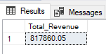

**2.Average order value**

select cast(cast(sum(total_price)as decimal(10,2))/ cast(count(distinct order_id)as decimal(10,2))as decimal (10,2))as Average_sales_per_order

from pizza_data

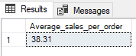

**3.Total pizza’s Sold**

select sum(quantity) as total_pizza_sold

from pizza_data

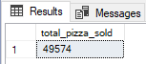

**4.Total Orders**

select count(distinct order_id) as total_orders

from pizza_data

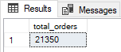

**5.Average Pizza Per Order**

select cast(

cast(sum(quantity)as decimal (10,2) )/ cast(count(distinct order_id)as decimal (10,2))

as decimal(10,2)) as Average_pizza_per_order

from pizza_data

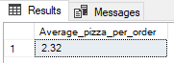

1. ***CHART REQUIREMENTS***

**1.Daily Trend For Sales**

Select datename (dw,order_date)as order_days,cast(sum(total_price) as decimal(10,2))as total_sales

from pizza_data

group by datename (dw,order_date)

order by 2

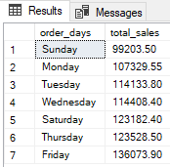

***Applying filter for the month of December***

Select datename (dw,order_date)as order_days,cast(sum(total_price) as decimal(10,2))as December_sales

from pizza_data

where month(order_date)=12

group by datename (dw,order_date)

order by 2

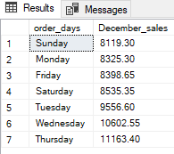

**2.Hourly Trend For sales**

select datepart(hour,order_time) as order_Hours,cast(sum(total_price)as decimal(10,2)) as total_sales

from pizza_data

group by datepart(hour,order_time)

order by 1

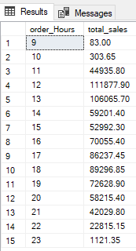

**3.Percentage of Sales by Pizza Category**

select pizza_category,cast(sum(total_price)*100/ (select sum(total_price) from pizza_data)as decimal(10,2))as sales_percentage

from pizza_data

group by pizza_category

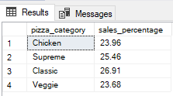

**4. Percentage of Sales by Pizza Size**

select pizza_size,cast(sum(total_price)*100/ (select sum(total_price) from pizza_data)as decimal(10,2))as sales_percentage

from pizza_data

group by pizza_size

order by 2

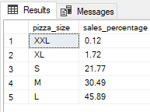

**5.Total Pizzas Sold by Pizza Category**

select pizza_category, sum(quantity) as Quantity_sold

from pizza_data

group by pizza_category

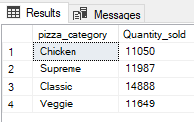

***Applying filter for the first quarter of the year (Jan-April)***

select pizza_category, sum(quantity) as Quantity_sold_Jan_April

from pizza_data

where datepart(quarter, order_date)=1

group by pizza_category

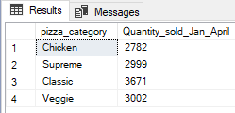

**6.Top 5 Sellers by Total Pizza Sold**

select top 5 pizza_name,sum(quantity) as quantity_sold

from pizza_data

group by pizza_name

order by quantity_sold desc

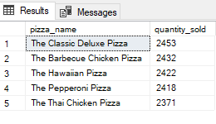

**7. Bottom 5 Worst Sellers by Total Pizza Sold**

select top 5 pizza_name,sum(quantity) as quantity_sold

from pizza_data

group by pizza_name

order by quantity_sold asc

